**Microsoft Hyper-V Monitoring Configuration Guide**

This article was updated to support v12.0 and newer of Goliath Performance Monitor.

**Prerequisites**

* Windows Server 2012 R2 – 2022
* Administrator level Credentials to access the Hyper-V Hosts/Servers

**Configure Monitoring**

This section will walk you through the discovery and configuration process for adding Hyper-V Hosts and its subsequent virtualized guest machines to your Goliath Performance Monitor inventory.

1. Navigate to the **Configure - Inventory** page
2. In the top right-hand corner, click the **menu** icon and chose the **Discovery** submenu option
   1. 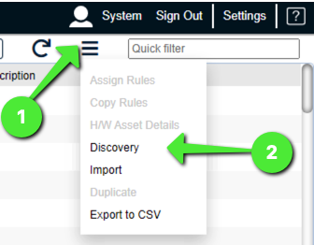
3. A new pane will appear, in the section for **Find Servers/Devices in IP Address**, enter the applicable subnet range that includes the Hyper-V Hosts and VMs you'd like to add for monitoring. Once finished click **OK.**
   1. Note, if the hosts/machines are spread across a very large subnet range it is suggested to enter smaller ranges and repeat these steps for each range
      1. For Example, if you are looking to bring in 10.10.1.10 to 10.10.1.100, and then 10.10.1.200 to 10.10.1.250, instead of doing once look up for 10.10.1.10 to 10.10.1.250 it is best to split the discovery into the two separate ranges versus the one large one.
      2. If you looking to add under 30 machines, and they are not in a consistent range it might be best to add these hosts/machines manually into inventory or via comma delimited list import. See the [Appendix](https://support.goliathtechnologies.com/hc/en-us/articles/360024132554-Microsoft-Hyper-V-Monitoring-Configuration-Guide#01FYVF5AGAS21Q335754GBEQTB) for additional details below.
   2. 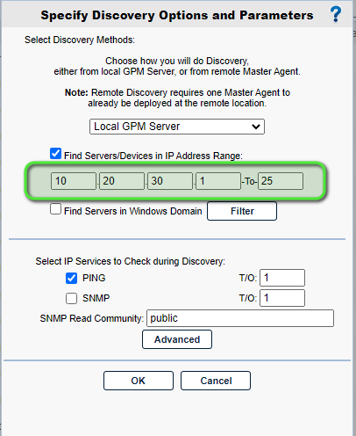
4. The technology will then begin to search the environment for the machines in the designated subnet range.
   1. Each item/IP Address will be searched for and displayed one at a time on the screen. At the top of the screen you will see a loading icon to confirm the technology is still going through the Discovery process
      1. 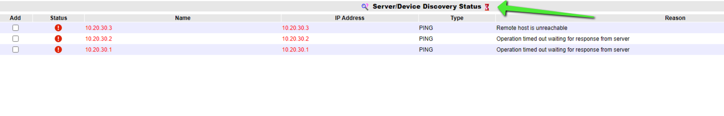
   2. If a machine exists for one of the IP Addresses included in the range you will see it appear on the screen with a green checkmark in the **Status** column. If a machine does not exist for one of the IP Addresses included in the range you will see it appear on the screen with a red exclamation in the **Status** column and the error details will be included in the **Reason** column
      1. If you are seeing a-lot of unexpected failures, you can click the **Stop** button at the bottom of the page to cancel the discovery and use a different method for adding the machines to the technology. See the [Appendix](https://support.goliathtechnologies.com/hc/en-us/articles/360024132554-Microsoft-Hyper-V-Monitoring-Configuration-Guide#01FYVF5AGAS21Q335754GBEQTB) for additional options.
      2. 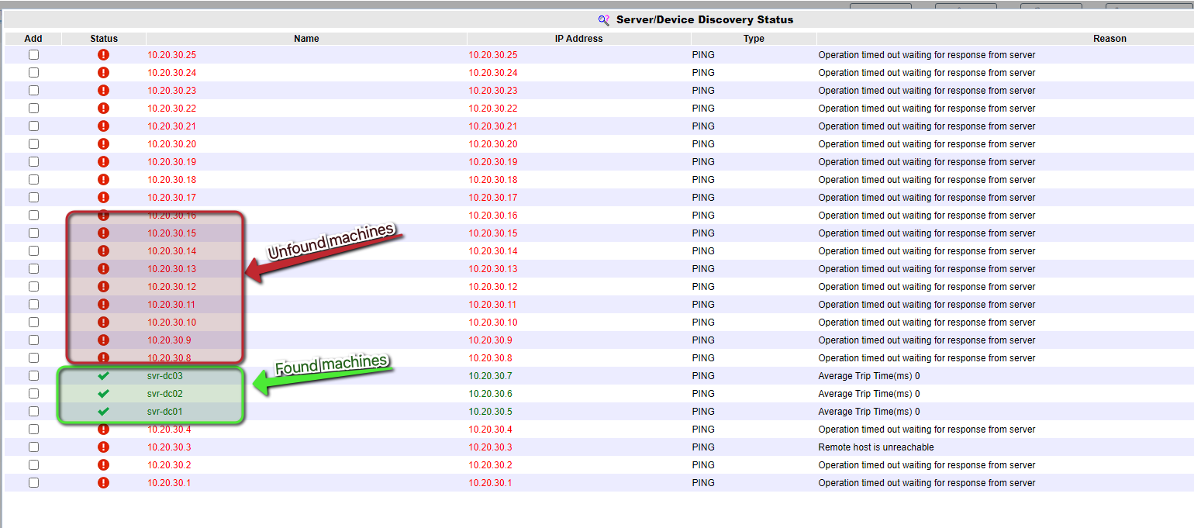
   3. When the discovery is complete you will no longer see the loading icon at the top of the page and the bottom left hand corner will show the message **Done Checking for IP Services**.
      1. 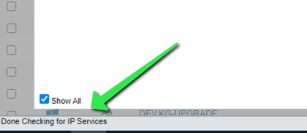
5. Once the discovery is complete, use the checkbox option in the **Add** column to select the host/machines you'd like to add to the technology and then click the **Add** button at the bottom of the page.
   1. Note - only select items that have a green checkmark in the Status column.
6. A prompt will appear to confirm the addition of the machine, click OK to proceed
   1. 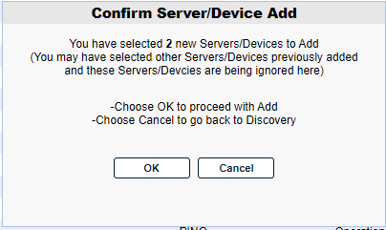
7. The technology will then take you back to the **Configure - Inventory** page while it imports the machines. The status of this process will be displayed in the bottom left hand corner. Do not navigate away from the page or perform any other actions until the message in the bottom left hand corner changes from "One Moment..." to "Usage Counts...". This indicates that the import has completed.
   1. Note - navigating away from the page or performing actions may cause the import to be canceled. If this occurs you must assess which machines were added vs not and repeat the above steps for the canceled machines.
   2. 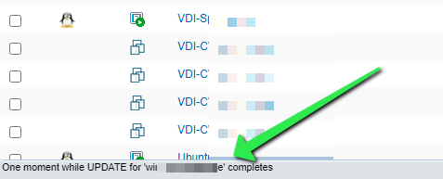
8. Once the hosts and machines are listed in inventory. Use one of the agent installation methods listed below to deploy the agent.
   1. Note - an agent is required for monitoring

**Goliath Agent Installation Methods:**

* [Agent Installation/Update via the Goliath Console](https://support.goliathtechnologies.com/hc/en-us/articles/360025093394)
* [Agent Installation/Update via Installer](https://support.goliathtechnologies.com/hc/en-us/articles/360025959993)
* [Agent Installation/Update for Gold Images, Master Images, App Layers, Instant Clones & Templates](https://support.goliathtechnologies.com/hc/en-us/articles/360025009874)
* [Silent Agent Installation/Update](https://support.goliathtechnologies.com/hc/en-us/articles/360025012374)
* [Agent Installation/Update via Command Line](https://support.goliathtechnologies.com/hc/en-us/articles/360025008894)

**Post Configuration**

Now that the above steps are completed, the agent should now be installed and connected to your Hyper-V hosts and VMs. With the agent installed, the technology will deploy its out of the box Windows Health monitoring. To configure custom monitoring and or enable alert notifications, please see the additional articles referenced below.

**Configure Custom Monitoring**:

* [PING Monitoring](https://support.goliathtechnologies.com/hc/en-us/articles/360045916854)
* [EventLog Monitoring](https://support.goliathtechnologies.com/hc/en-us/articles/360024449253)
* [Process Monitoring](https://support.goliathtechnologies.com/hc/en-us/articles/360024501133)
* [Windows Service Monitoring](https://support.goliathtechnologies.com/hc/en-us/articles/360024346774)
* [Performance Counter Monitoring](https://support.goliathtechnologies.com/hc/en-us/articles/360024176614)
* [File/Folder Monitoring](https://support.goliathtechnologies.com/hc/en-us/articles/360024335974)
* [Configure Advanced Watch Rules](https://support.goliathtechnologies.com/hc/en-us/articles/360024347953)

**Enabling Alert Notifications:**

* [Configure Email and Text Alert Notifications](https://goliathtech.zendesk.com/hc/en-us/articles/360024446933)
* [Configure SNMP Alert Notifications](https://goliathtech.zendesk.com/hc/en-us/articles/360024726913)
* [Configure Syslog Alert Notifications](https://goliathtech.zendesk.com/hc/en-us/articles/360024346594)

**Appendix**

**Manually Add Hosts/Machines to Inventory**

1. Navigate to the **Configure - Inventory** page
2. Click the **New** button at the page of the page
3. A new pane will appear, fill out the following fields and then click the **Save** button
   1. *Server/Device Name*: Enter the hostname, not FQDN, of the host/machine
   2. *Primary IP Address*: Click the Add button to the right of the field to enter the machines IP Address
   3. *Description*: Optionally, define a description for the host/machines
   4. *Member of Primary Group:* Use the dropdown menu to organize the machine into a group.
      1. The default group is the Auto Register Group but custom groups can be created at a later point and the machine can later be reorganized
   5. *Member of Windows Domain/Workgroup:* Use the drop menu to assign the machine to a domain.
      1. It is ok if the machine is not assigned to the correct domain initially, the field just must have data in order to push the agent. Once the agent connects the domain will be updated.
4. Repeat Steps 2 & 3 for each host/machine you would like to add for monitoring
5. Install the Goliath Agent to the new hosts/machines
   1. See the agent installation methods above for full details

**Import Machines to Inventory via CSV**

1. Navigate to the **Configure - Inventory** page
2. In the top right hand corner, click the **menu** icon and chose the **Import** submenu option
   1. 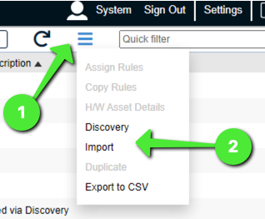
3. A new pane will appear. Enter, or Copy & Paste, a comma-delimited list for importing and batch adding new Servers/Devices. The format is one entry per line of:
   1. Server/Device Name, IP Address, Description, Group Name, Server Domain/Workgroup
      1. **Ensure that the Group Name value matches a Group of the Primary Group type on the Configure - Groups page.**
      2. **Ensure the Server Domain/Workgroup value matches a domain name that is already configured in the technology (case sensitive).**
         1. This can be confirmed by editing any inventory item and reviewing the **Member of Windows Domain/Workgroup** dropdown menu options
   2. Note, only Server/Device Name and IP Address are required for import. However, a domain name must be configured if you will be install the agent from the console.
   3. 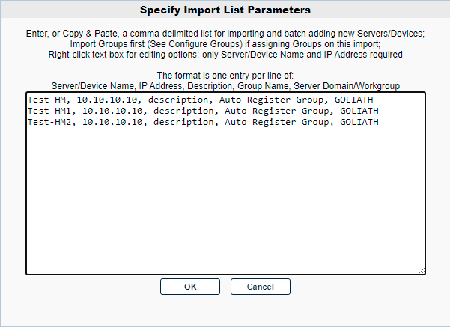
4. Click the **OK** button to import the specified servers/devices to the GPM database
   1. You will be prompted when the import completes. Reload the Configure - Inventory page to see the new machines listed
      1. 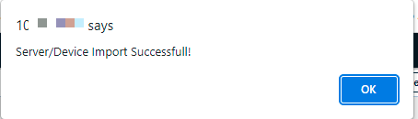
      2. 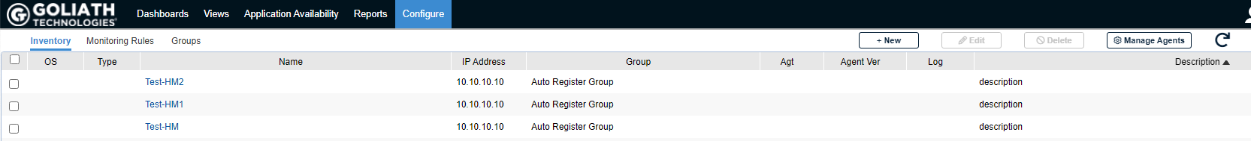
5. Install the Goliath Agent to the new hosts/machines
   1. See the agent installation methods above for full details